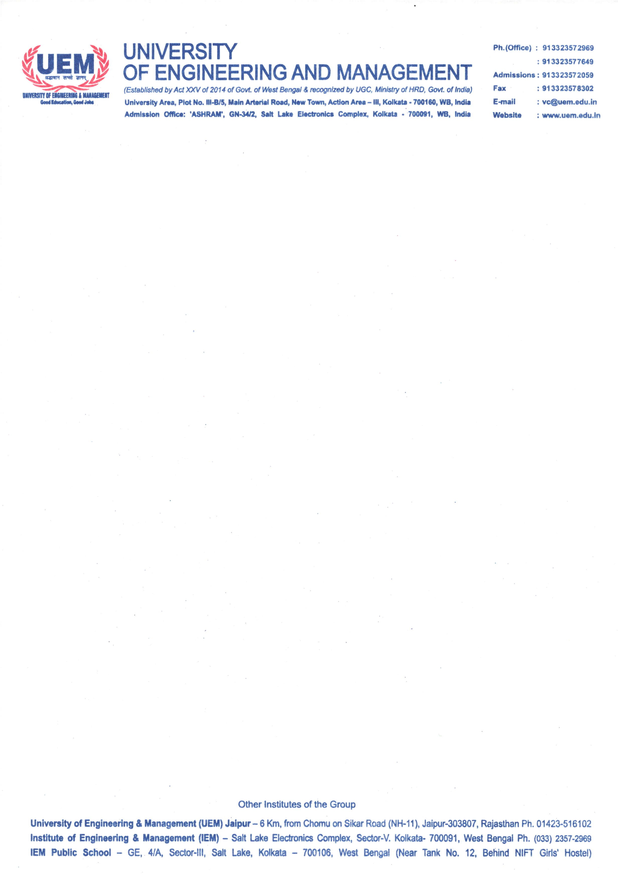

CERTIFICATE

This is to certify that the project titled “StudyBuddy AI: A Generative Artificial Intelligence based
Study Planner” submitted by Ahan Ghoshal (University Registration No. 304202200901241 of 2022–2023), Ankush Dutta (University Registration No. 304202200900709 of 2022–2023), Anoushka Bhadra (University Registration No. 304202200900711 of 2022–2023), Ayushman Dutta (University Registration No. 304202200901160 of 2022–2023), and Saumi Sengupta (University Registration No. 304202200901182 of 2022–2023), students of University of Engineering and Management, Kolkata, in partial fulfilment of requirement for the degree of Bachelor of Technology in Computer Science and Engineering (Artificial Intelligence and Machine Learning), is a Bonafide work carried out by them under the supervision and guidance of Prof. (Dr.) Sudipta Sahana during the 8th Semester of academic session 2025–2026. The content of this report has not been submitted to any other university or institute. We are glad to inform you that the work is entirely original and its performance is found to be quite satisfactory.

________________________________ ____________________________________
Signature of Mentor Signature of Head of Department
Department of CSE (AI & ML) Department of CSE (AI & ML)

